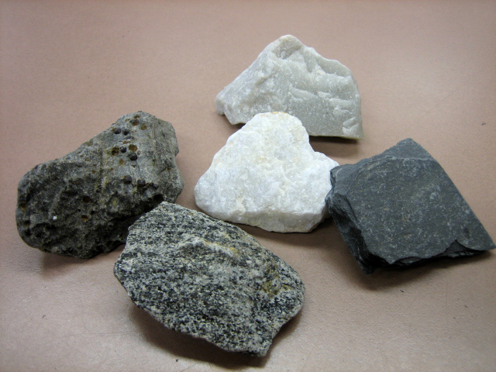

Metamorphic rocks are either igneous or sedimentary rocks that are changing. The word ‘metamorphic’ comes from the Greek words meta, meaning ‘after’, and morphe, meaning ‘change’, so it literally means ‘after change’. Metamorphic rock is rock that is changing its form.
Sedimentary and igneous rock subjected to higher pressures and intense heat will start to change in density, crystal structure and other properties. This process of change takes millions of years and doesn’t stop.
Gneiss is an example of metamorphic rock. Gneiss is formed from metamorphosed granites or sandy marine sediments. The rock cycle shows that this happens due to the heat and pressure of the surrounding rocks deep within the Earth.
Metamorphic rocks are difficult to identify. They have properties of the original rock they are changing from, but also have new properties due to the changes it has undergone. These properties can include new crystal structures and thinner, stronger banding or foliation.

Give the meaning of the following words in the paragraphs above:

1. Subjected _____________________________________________________________

2. Intense _______________________________________________________________

3. Properties _____________________________________________________________

4. Marine _______________________________________________________________

5. Sediments _____________________________________________________________

6. Surrounding ___________________________________________________________

7. Identify _______________________________________________________________

8. Original ___________________________________________________________
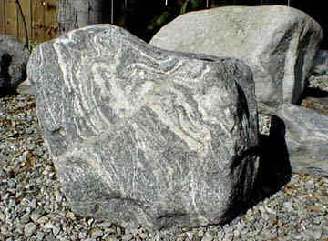

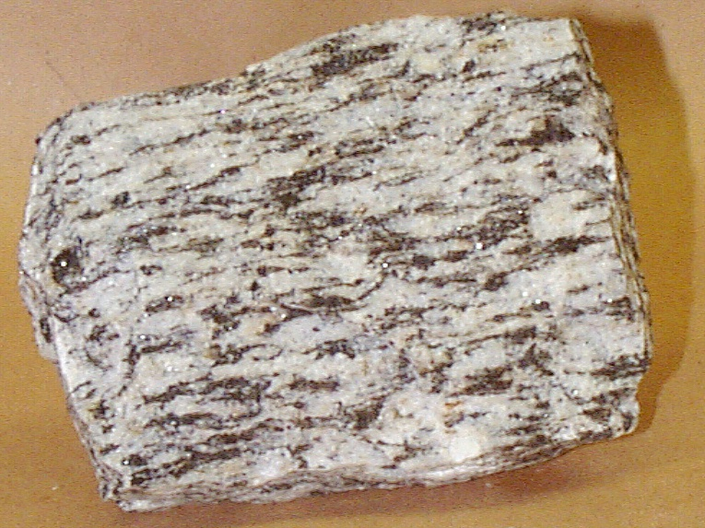
Which words or phrases in the text can be replaced with the following:

1. Structure______________________________________________________________

2. Put under _____________________________________________________________

3. Extreme ______________________________________________________________

4. Characteristics _________________________________________________________

5. Procedure _____________________________________________________________

6. Ocean ________________________________________________________________

7. Tricky ________________________________________________________________

8. Narrower_____________________________________________________________
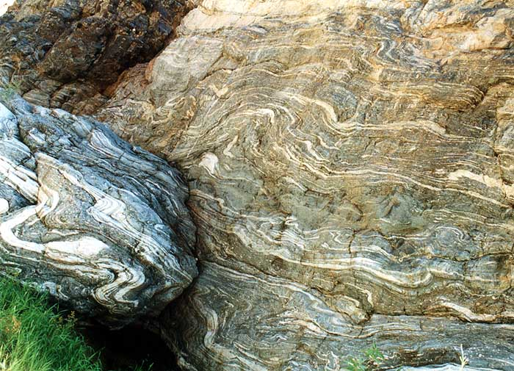

Questions

1. What are metamorphic rocks? __________________________________________

__________________________________________________________________

2. What does metamorphic mean? ________________________________________

__________________________________________________________________

3. What is it that changes in sedimentary and igneous rocks that are subjected to pressure and heat? __________________________________________________

__________________________________________________________________

4. Give an example of a metamorphic rock and its parent rock _________________

__________________________________________________________________

5. Why are metamorphic rocks sometimes difficult to identify? _________________

______________________________________________________________________

